JEL Classification: А10, В40

TITLE OF THE ARTICLE

Sergey Petrov, Boris Ivanov, Vladimir Petrov
Head of department « », professor, Doctor of Technical Sc.;
associate professor, PhD; postgraduate
Bauman University, Moscow
prefix@domain.ru, another_author@mailservice.ru

Abstract: a brief description of the article. Abstract shows the distinctive features and advantages of published work, helps readers navigate their choice. Size of abstracts is no more than 5-6 lines (no more than 500 characters including spaces).
Keywords: word, word, word.

REQUIREMENTS FOR REGISTRATION OF PUBLICATIONS
This file is prepared according to the rules and can be used as a template.
For publication, you must provide a computer version of the materials (typed in Microsoft Word).
The material is placed on an A4 page (210 x 297 mm), all margins are 20 mm. All text is typed in Times New Roman Cyr font size 12 PT. Paragraph indent 12.5 mm. Interval-1.15 PT. Additional paragraph spacing - 0 PT. Do not put blank lines between paragraphs. Transfers are not allowed. The alignment of the boundaries of the text – in width. The total text should not exceed 20,000 characters with spaces, including output and bibliography.
All abbreviations (including abbreviations) in the text must be deciphered. The terms, units and symbols used in the articles should be generally accepted. We kindly ask you to check the text for spelling and syntax errors, and files for viruses.
In the text, it is allowed to highlight words or phrases in bold or italic. Underscores are not allowed.
Please distinguish between dashes and hyphens.
You must leave a blank line before the section name. There is no period after the section name.
Figures should be executed accurately in any format imported by Microsoft Word, their sizes should not exceed the size of the text field. If the drawing consists of several objects, all of them should be combined into one object. All figures should be numbered and signed as shown in the example. In the text of the manuscript, a reference to each figure is necessarily given (figure 1). Numbering through. Figure captions are recommended in Times New Roman, 12 PT. After the caption to the picture, you must leave an empty line. Drawings should be done in black and white, or in shades of gray. Colour drawings and photographs are not allowed.

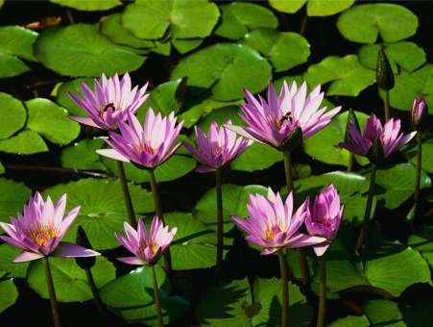
Figure 1. Water lily
Formulas must be typed using the built-in Equation Editor. The use of other formula editors, such as MathType, is not welcome. Formulas are located in the center of the line, the numbering of formulas is through throughout the text, the numbers of formulas are located on the right.
Mathematical symbols of variables in the text and in the illustrations should be typed: Latin-italics, Russian and Greek-direct; words-operators (min, max, sin, cos, etc.) - direct.
If there are tables in the text, they must also be numbered and signed. Numbering through. The tables are signed in the upper right corner, as shown in the example. As for figures, headings and table contents should be typed in a font size of 12 PT. You must leave an empty row after the table. Each table must be referenced in the text (table 1).
Table 1
Name of the table
№ | Сolumn 1 | Сolumn 2 | Сolumn 3
1 | … | … | …
2 | … | … | …
3 | … | … | …
4 | … | … | …

List using bullets are made on the basis of the following examples:
- marker-dash;
- indentation - as in the example;
- if there is a semicolon at the end of a line, the next line begins with a small letter. At the end of the list of shootouts put a period.

The numbered list is designed as in the example below:
1. The numbers are in Arabic numerals. Indentation-as in the example.
2. After the number, a period is placed.
3. After the dot, the text is written with a capital letter. At the end of a dot.

When referring to a source, if there is a literature review, after mentioning it in the text, put down in square brackets the number under which it appears in the list of references, for example, [9]; it is possible to specify the author's name and year of issue, for example (Ivanov, 2012). When referring in the text of the manuscript to the work of the author, be sure to indicate, for example (Ivanov, 2012, P. 24-31), or (9. p. 23, P. 45-47).
The list of references is made according to GOST 7.0.5-2008 "Bibliographic description of the document. General requirements and rules of registration". An example of the design is given below. Before the list of references put the word "REFERENCES" without a period.

REFERENCES
- Sourse 1
- Source 2
- …

